HW 6

CCN

Final hw

1. Answer below

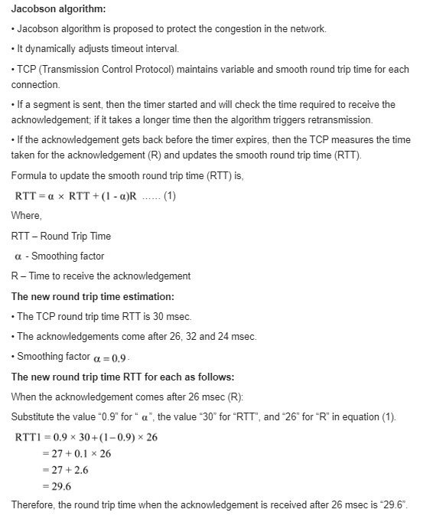

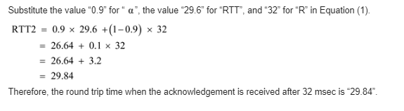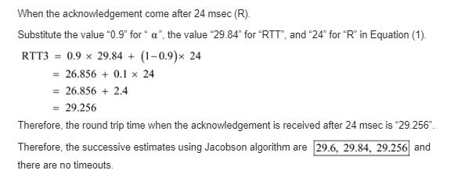

Hope that is enough information in my calculations, thank you.

1. One window can be sent every 20 msec. This would give 50 windows/sec and a maximum data rate of about 3.3 million bytes/sec. So, the line efficiency would be 26.4 Mbps/1000 Mbps or 2.6 percent.
2. So we are trying to send 232 bytes in 120 sec or 35,791,394 payload bytes/sec,which would be 23,860 1500-byte frames/sec. The TCP and IP overhead are 20 bytes.While Ethernet overhead is 26 bytes(all given). This means that for 1500 bytes of payload, 1566 bytes must be sent. If we are to send 23,860 frames of 1566 bytes every second, we need a line of 299 Mbps. We will run the risk of two different TCP segments having the same sequence number at the same time if we run anything faster.
3. A sender cannot send more than 255 segments, 255 × 128 × 8 bits, in 30 sec. The data rate cannot exceed (255x128x8/30) 8.704 kbps.